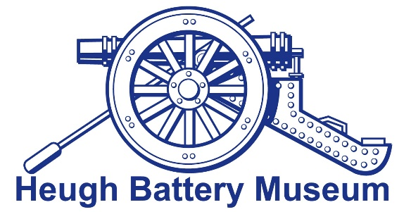

If you have an object you think the museum would benefit from for their collection, please complete as much of the following information as you can. The more information we have about an object, the better decisions we can make about adding it to our collection and how we might use it – and the better the story we can tell our visitors about it if we do accept it.

If we decide not to accept your object into the collection would you like us to (please delete as appropriate):
- return it to you
- dispose of it on your behalf

About your object:

How did it come into your possession?

How long have you had it?

Who owned it originally? (Include information like their name, date of birth/death, occupation and any relevant family history).

How was the item used and by whom? (Was the item used for something different to what it was made for? For example: an iron used as a bookend or doorstop)

What did you call it? (local dialect/nick names)

When was the item made and by whom?

For military items - name of regiment, years of service, location of military action, etc.

Is there anything else you would like to tell us about the object or the people who owned it?

Thank you for completing this form. If you have any photos that might help us to tell the story please send copies or scans.

